Praktikum 3 Sistem Basis Data 2025
NRP / Nama : 5025251143 / Ahmad Fakhrul Bawani
Kelas : C
RDBMS : MySQL Workbench 8.0
Link SQL :
Kode Asdos : SBDC003
Sesi : Modul Pendahuluan / Praktikum

Nomor 1
Sintaks:
SELECT nama_resepsionis, usia, alamat FROM resepsionis
WHERE usia IN (
SELECT MIN(usia) FROM resepsionis
WHERE jenis_kelamin = 'L'
);

Hasil:
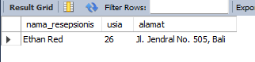
Nomor 2
Sintaks:
SELECT -- DISTINCT
pl.nama_pelanggan, ps.jumlah_kamar, km.nama_kamar -- COUNT(ps.id) AS banyak_order
FROM pelanggan pl
INNER JOIN pesanan ps ON pl.NIK = ps.pelanggan_NIK
INNER JOIN order_kamar ok ON ps.id= ok.order_id
INNER JOIN kamar km ON ok.kamar_nomor = km.nomor
WHERE pl.nama_pelanggan = 'Daniel Martinez';
-- GROUP BY pl.nama_pelanggan, ps.jumlah_kamar, km.nama_kamar
-- HAVING pl.nama_pelanggan = 'Daniel Martinez';

Hasil:
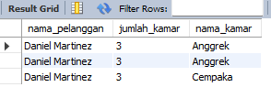
Nomor 3
Sintaks:
SELECT rs.id, rs.nama_resepsionis, rs.no_telp FROM resepsionis rs
WHERE rs.id IN (
SELECT ps.resepsionis_id FROM pesanan ps
WHERE ps.jumlah_kamar > 2
);

Hasil:
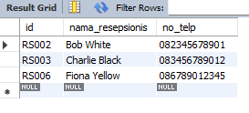
Nomor 4
Sintaks:
SELECT * FROM kamar km
WHERE km.status = 'Tersedia';

Hasil:
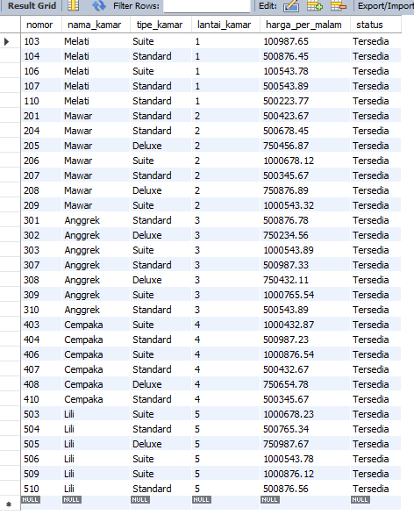
Nomor 5
Sintaks:
SELECT km.nomor, km.nama_kamar, km.tipe_kamar FROM kamar km
WHERE km.nomor IN (
SELECT kf.kamar_nomor FROM kamar_fasilitas kf
WHERE kf.fasilitas_id IN (
SELECT fl.id FROM fasilitas fl
WHERE fl.nama = 'Wi-Fi'
)
);

Hasil:
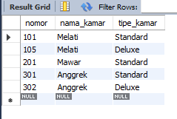
Nomor 6
Sintaks:
SELECT
SUM(total_harga_kamar) AS total_semua_order,
AVG(total_harga_kamar) AS rata_rata_per_order
FROM (
SELECT
SUM(COALESCE(fl.harga_per_fasilitas * kf.jumlah_fasilitas, 0) + DATEDIFF(ps.tanggal_checkout, ps.tanggal_checkin) * km.harga_per_malam) AS total_harga_kamar
FROM pesanan ps
INNER JOIN order_kamar ok ON ps.id = ok.order_id
INNER JOIN kamar km ON ok.kamar_nomor = km.nomor
LEFT JOIN kamar_fasilitas kf ON km.nomor = kf.kamar_nomor
LEFT JOIN fasilitas fl ON kf.fasilitas_id = fl.id
JOIN pembayaran pb ON ps.id = pb.order_id
WHERE pb.status = 'Lunas'
GROUP BY ps.id
) AS per_order;

Hasil:
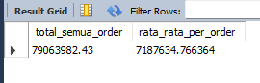

Nomor 7
Sintaks:
SELECT
pl.NIK, pl.nama_pelanggan, pl.no_telp, km.nama_kamar, km.nomor, km.tipe_kamar
FROM pembayaran pb
INNER JOIN pesanan ps ON pb.order_id = ps.id
INNER JOIN order_kamar ok ON ps.id = ok.order_id
INNER JOIN kamar km ON ok.kamar_nomor = km.nomor
INNER JOIN pelanggan pl ON ps.pelanggan_NIK = pl.NIK
WHERE pb.status = 'Belum Lunas';

Hasil:
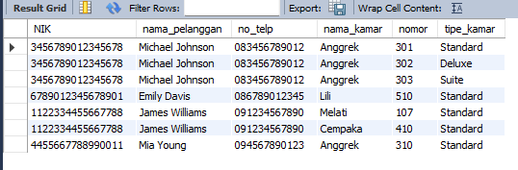
Nomor 8
Sintaks:
SELECT km.nomor AS no_kamar, fl.nama AS nama_fasilitas FROM kamar km
INNER JOIN kamar_fasilitas kf ON km.nomor = kf.kamar_nomor
INNER JOIN fasilitas fl ON kf.fasilitas_id = fl.id
WHERE km.tipe_kamar = 'Deluxe';

Hasil:
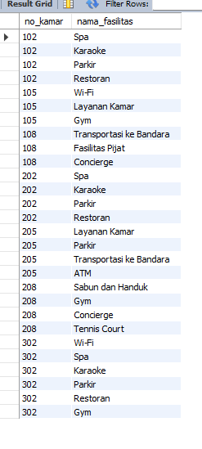
Nomor 9
Sintaks:
SELECT fl.nama, SUM(kf.jumlah_fasilitas) AS banyak_fasil FROM fasilitas fl
INNER JOIN kamar_fasilitas kf ON fl.id = kf.fasilitas_id
GROUP BY fl.nama
ORDER BY banyak_fasil DESC;

Hasil:
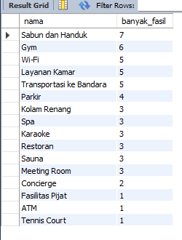
Nomor 1
Sintaks:
SELECT * FROM pelanggan pl
WHERE pl.NIK LIKE '12%';

Hasil:
